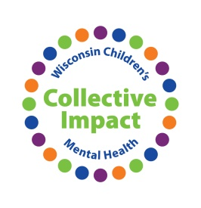
Vicarious Trauma │ Secondary Trauma │ Self Care
Action Plan
This Action Plan is for your personal use. You are encouraged to complete it with the ideas you learn in this workshop and then take it back to your organization for discussion on becoming more aware of vicarious trauma, secondary trauma, and self-care.

What are 3 concrete things you learned from the panel in recognizing/dealing with vicarious trauma, secondary trauma, and self-care that you can take back to your organization for discussion?
- ___________________________________________________________________________

- ___________________________________________________________________________

- ___________________________________________________________________________

What are 3 things that you can do as an individual in your organization to be more aware of and deal with vicarious trauma, secondary trauma, and self-care?
- ___________________________________________________________________________

- ___________________________________________________________________________

- ___________________________________________________________________________

What are 1 – 3 challenges/barriers you anticipate facing in being more understanding of vicarious trauma, secondary trauma, and self-care? What can you do to address those?

Challenge | Addressing Challenge

Who will you need to involve to move your organization in being more aware of/dealing with vicarious trauma, secondary trauma, and self-care?

Goal: ______________________________________________________________________________

___________________________________________________________________________________

Steps to Achieve Goal

 | Task | Responsible | Timeframe
1
2
3
4
5
6
7
8
9
10

Comments/Notes:

